Namal University Mianwali
Department of Computer Science
Assignment 3: Implementation, Statistical Exploration,
and Experimental Evaluation
Course: CSC-355 Natural Language Processing
Instructor: Dr. Muzamil Ahmed
Project Title:
"Sentiment Analysis of Code-Switched Urdu-English Social Media Text Using Multilingual Transformer Models"
Submitted By:
Jalal Ur Rahman (NUM-BSCS-2022-42)
Sultan Haider
Date: 20-05-2026

1. Dataset Analysis and Statistical Exploration
In accordance with the objectives of Milestone 3, we have conducted a thorough statistical exploration of the dataset selected for our project. The primary dataset is derived from the SemEval-2020 Task 9 (SentiMix) Hinglish dataset, which comprises authentic code-mixed social media text. Code-mixed text is highly representative of Pakistani digital communication, wherein Roman Urdu and English are integrated seamlessly. The statistical profile of the parsed sentence-level corpus is summarized in the table below:
Metric Description | Value
Total Social Media Posts (Tweets) | 18631
Total Tokens | 278348
Average Post Length (Tokens) | 14.94
Maximum Post Length (Tokens) | 56
Positive Sentiment Count | 6208
Neutral Sentiment Count | 6829
Negative Sentiment Count | 5594
English-like Script Tokens Count | 261519
Urdu / Roman Urdu Keyword Tokens Count | 16829

The sentiment distribution shows that the dataset is relatively balanced, with neutral opinions constituting the largest portion (approx 37.3%), followed by positive (33.3%) and negative (29.5%) sentences. This makes macro F1-score and accuracy reliable benchmarks since class imbalance is minimal. To visually investigate the structural properties of our dataset, we generated five analytical plots:
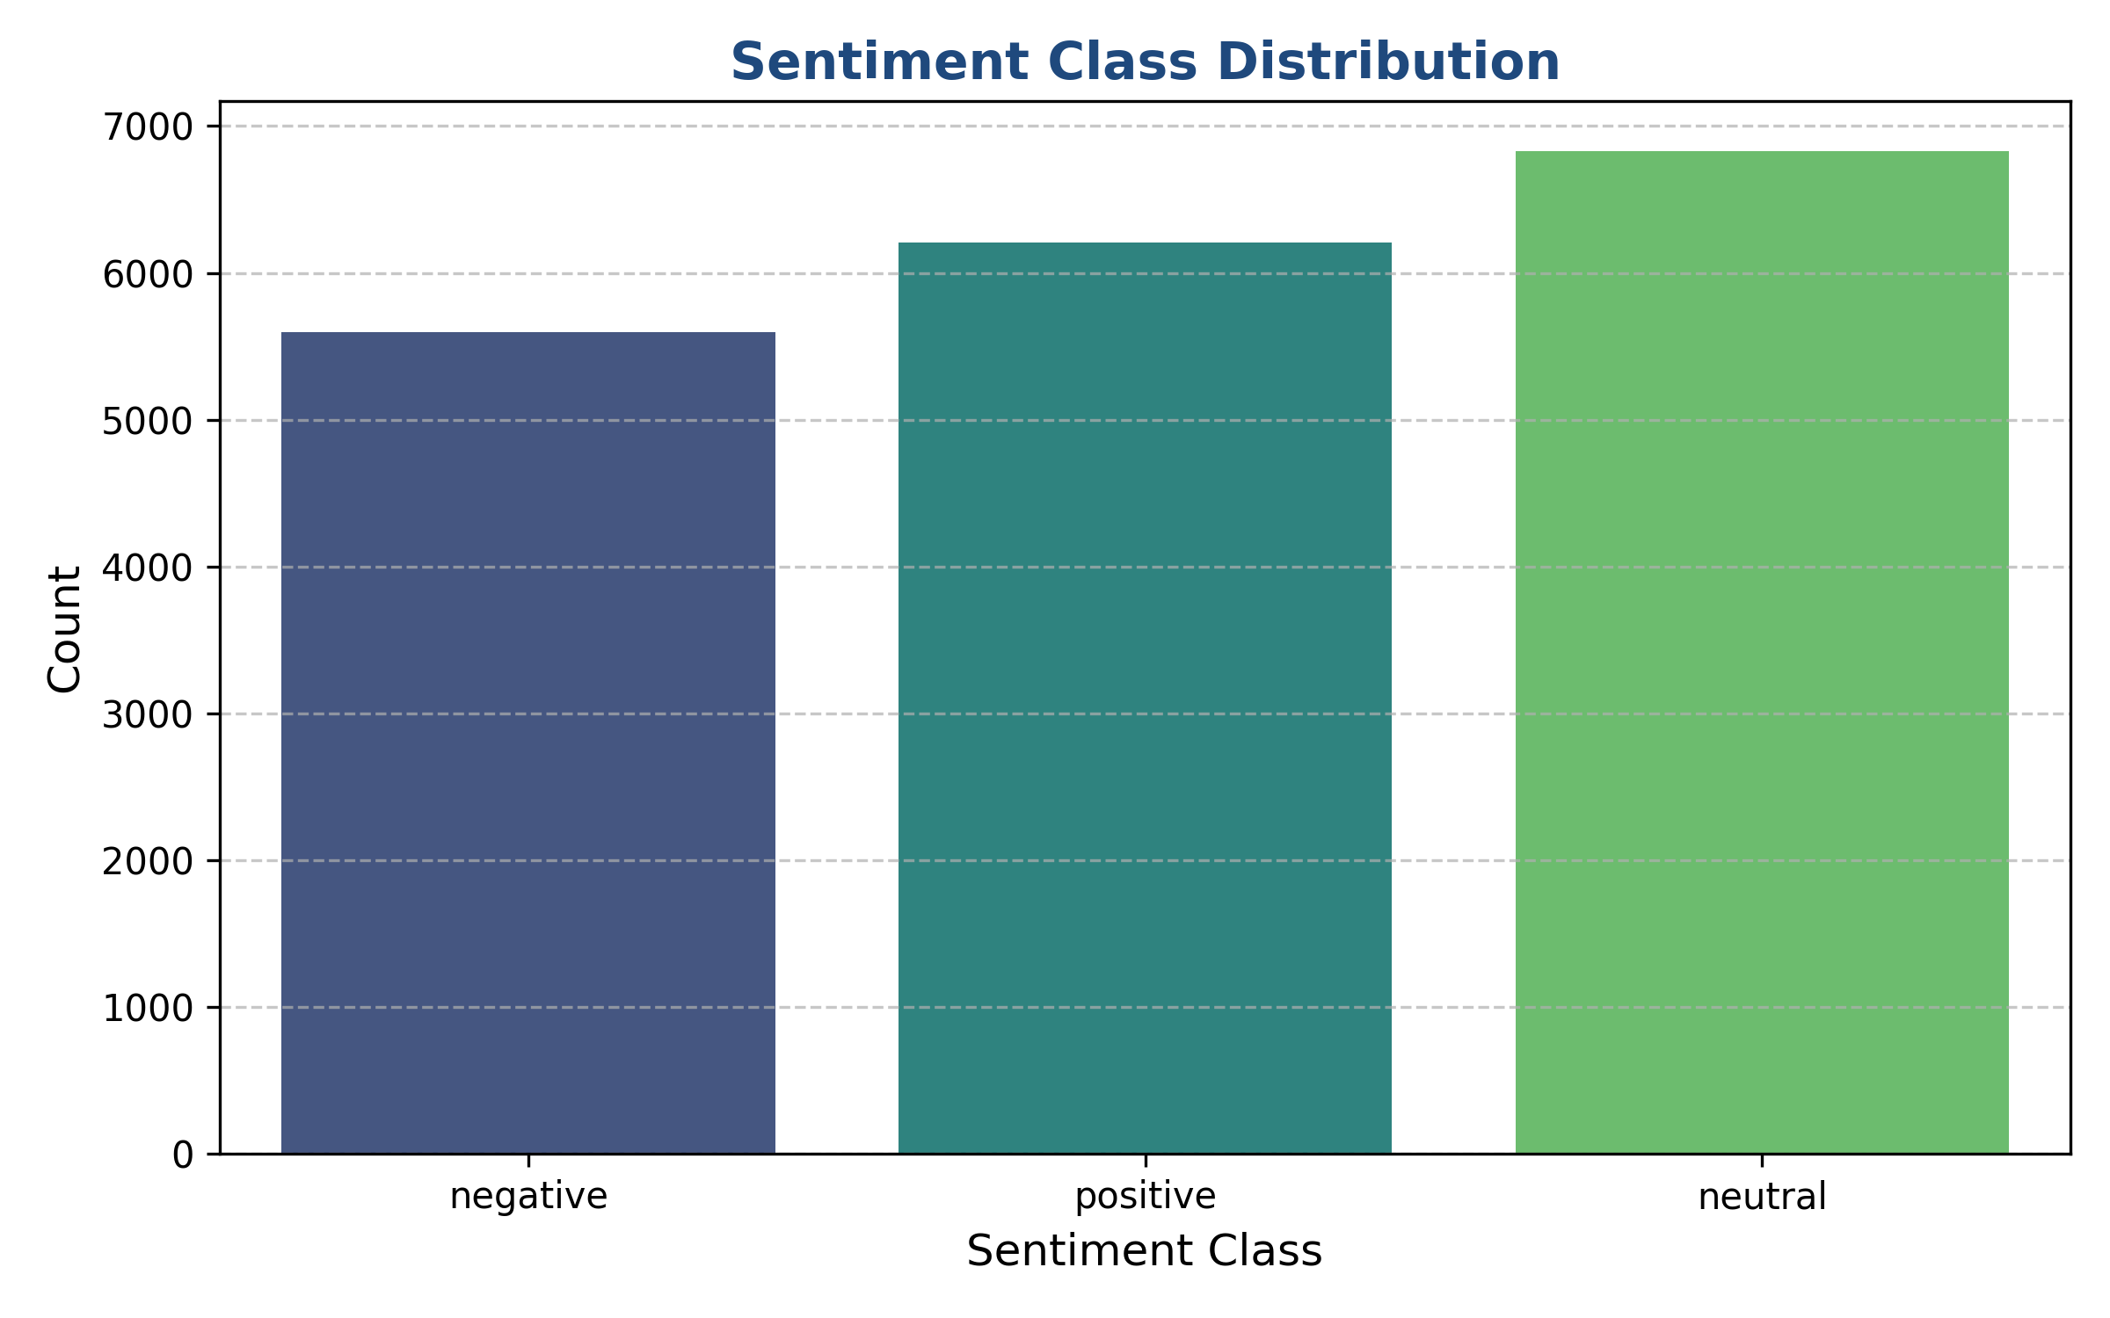
Figure: Sentiment Class Distribution (Positive, Negative, Neutral)
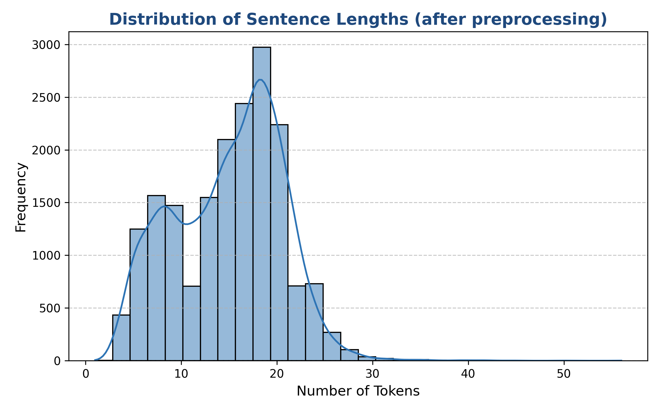
Figure: Post Length Distribution showing token frequencies per sentence
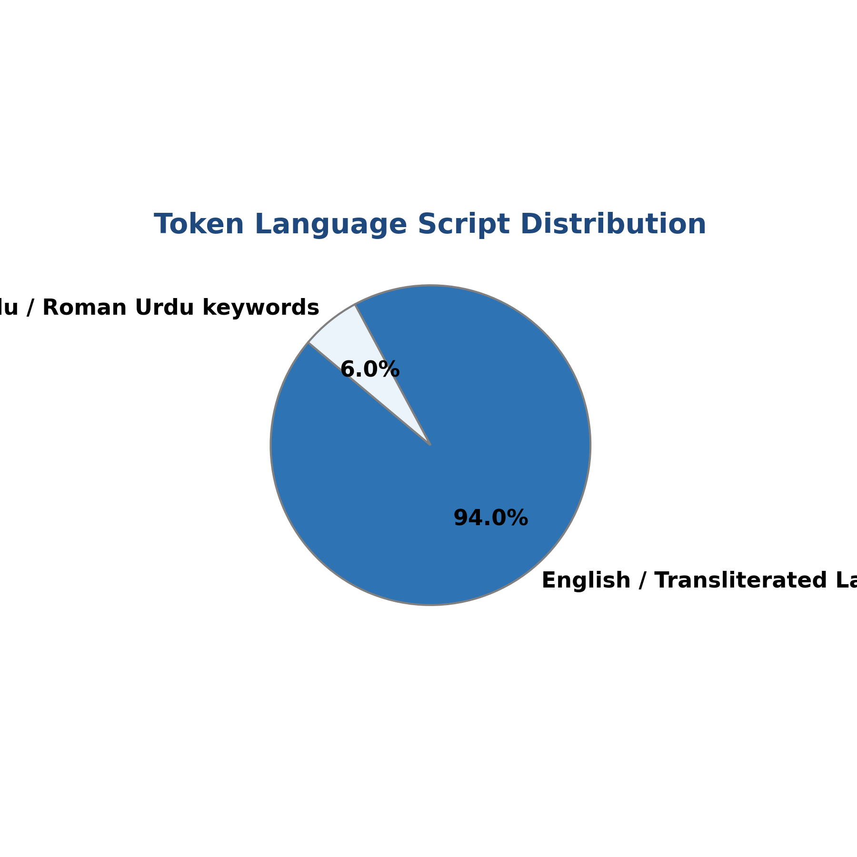
Figure: Bilingual Token Script Distribution (English vs. Roman Urdu Keywords)
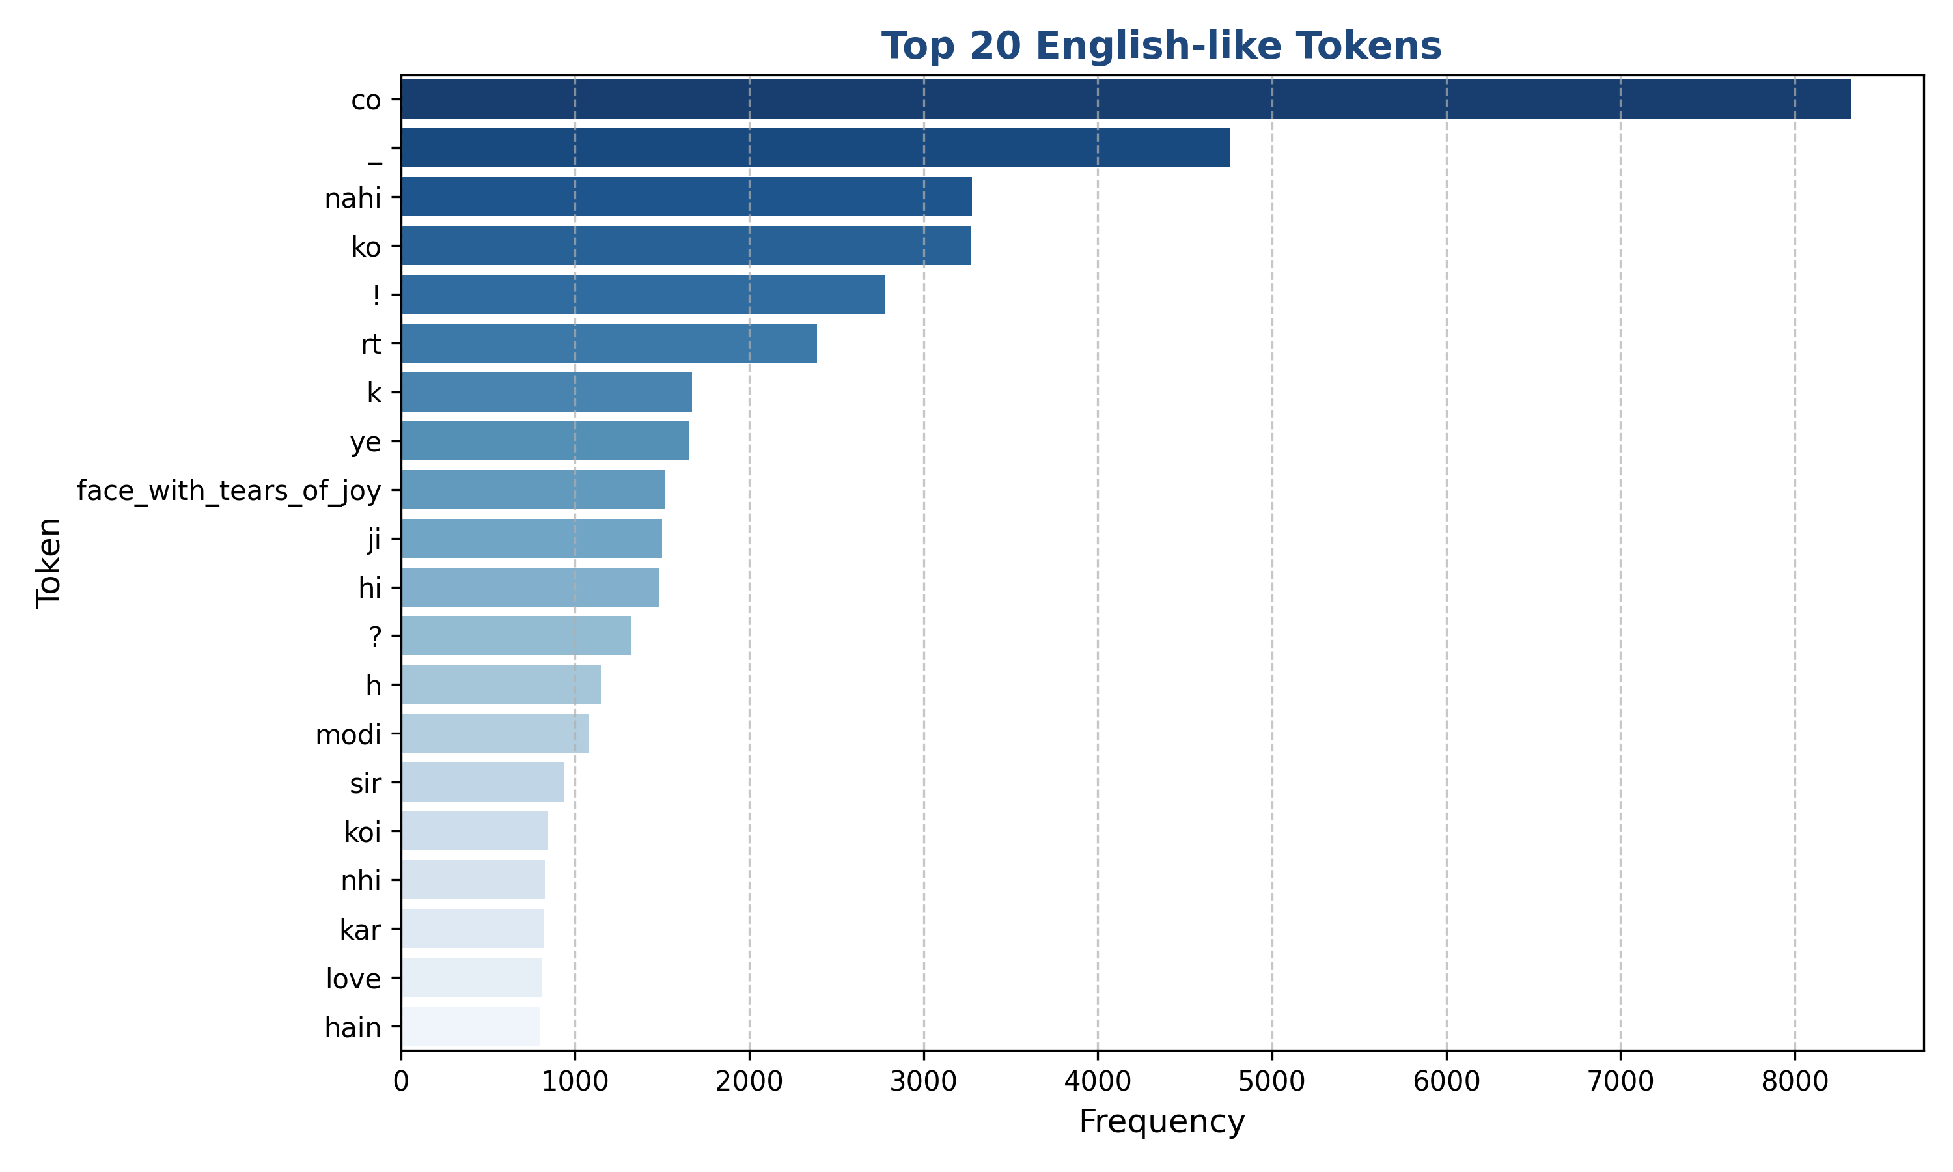
Figure: Top 20 Most Frequent English-like Tokens
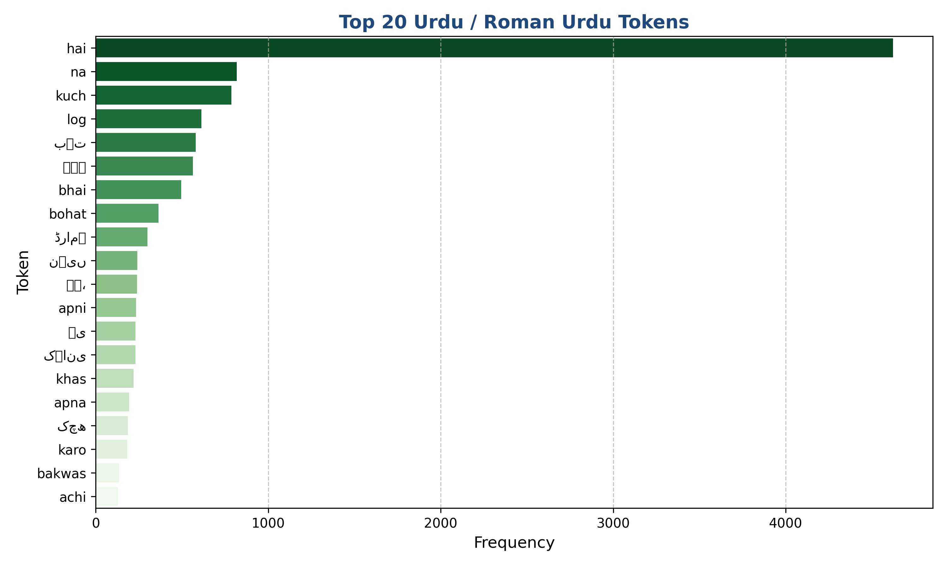
Figure: Top 20 Most Frequent Urdu / Roman Urdu Tokens
Discussion of Statistical Visualizations: The exploratory analysis reveals several key linguistic findings:
- Class Distribution: Minimal class imbalance reduces model bias toward a majority class and ensures that the loss functions optimize generalizable decision boundaries.
- Post Lengths: The post length histogram shows a right-skewed distribution centered around 15–20 words, with a maximum length of 56. This means sequence lengths can be padded to 60 without losing significant context, optimizing GPU/CPU memory during model training.
- Linguistic Density: Token-level language tags indicate that while English words are frequent, Roman Urdu keywords constitute critical sentiment markers, requiring bilingual preprocessing and contextual representation.
1.1 Why Selected Dataset is Suitable:
The SentiMix SemEval-2020 Task 9 corpus is highly suitable because it represents the actual, noisy, and unconstrained nature of code-switched text generated by South Asian social media users. It shares significant grammatical structures and lexical vocabularies with Roman Urdu, making it a valid benchmark for transfer learning.
1.2 Linguistic Challenges Present in the Dataset:
1. Spelling Variations: Roman Urdu has no standardized orthography. The word 'acha' can be written as 'accha', 'achha', or 'cha'.
2. Code-Switching Boundaries: Mid-sentence language transitions introduce severe syntactic ambiguity.
3. Polysemy and Slang: Informal social media writing contains phonetic transliterations, abbreviations, and emojis that act as strong sentiment markers but violate formal grammars.
1.3 Impact of Preprocessing Decisions:
Unicode normalization (NFC) resolves character representation inconsistencies. Emoji-to-text conversion using the emoji library preserves vital emotional states (e.g. converting 😡 to 'angry_face') as features, which otherwise would be discarded. Mention and URL removal removes highly variable, non-informative noise, improving training convergence. Bilingual stopword filtering reduces vocabulary size by removing low-value function words in both English and Urdu scripts.

2. Proposed Architecture and Mathematical Modelling
The proposed NLP system consists of three distinct experimental architectures to investigate the trade-off between feature engineering, sequential modeling, and deep contextual representations:
- Baseline Architecture (TF-IDF + Logistic Regression): Converts sentences into n-gram features weighted by term importance, classified via a linear model.
- Deep Learning Sequence Architecture (BiLSTM): Learns dynamic sequence representations by passing tokens through an embedding layer and a bidirectional Recurrent Neural Network (LSTM), capturing both forward and backward contextual states.
- Transformer Architecture (mBERT): Leverages a pre-trained Multilingual BERT model with 12 self-attention layers to extract deep, cross-lingual contextual subword representations, fine-tuned with a linear classification head.

2.1 Mathematical Foundations
A. 1. Term Frequency-Inverse Document Frequency (TF-IDF):
The TF-IDF score weights token importance based on its frequency in the document and sparsity across the corpus:
TF-IDF(t, d, D) = TF(t, d) * IDF(t, D)
TF(t, d) = f_(t,d) / sum_(t' in d)(f_(t',d))
IDF(t, D) = log( 1 + |D| / (1 + |{d in D : t in d}|) ) + 1
B. 2. Bidirectional LSTM Sequence Transition:
For each word input x_t, the LSTM cell computes hidden state h_t and cell memory c_t via input (i), forget (f), output (o), and cell candidate (g) gates:
f_t = sigmoid(W_f * x_t + U_f * h_(t-1) + b_f)
i_t = sigmoid(W_i * x_t + U_i * h_(t-1) + b_i)
g_t = tanh(W_c * x_t + U_c * h_(t-1) + b_c)
c_t = f_t * c_(t-1) + i_t * g_t
o_t = sigmoid(W_o * x_t + U_o * h_(t-1) + b_o)
h_t = o_t * tanh(c_t)
The bidirectional architecture runs both forward and backward LSTMs, concatenating their final hidden states:
h_t^(bi) = [h_t^(forward) ; h_t^(backward)]
C. 3. Self-Attention Score Computation (mBERT):
In the Transformer architecture, input embeddings are projected into Queries (Q), Keys (K), and Values (V) matrices. The attention weights are calculated via scaled dot-product:
Attention(Q, K, V) = Softmax( (Q * K^T) / sqrt(d_k) ) * V
Where d_k is the dimension of the key vectors. Softmax is applied to normalize attention weights:
Softmax(z_i) = exp(z_i) / sum_j(exp(z_j))
D. 4. Loss Function (Cross-Entropy Loss):
For multiclass classification (3 sentiment states), the cross-entropy loss function is minimized:
Loss = - 1/N * sum_(i=1)^N sum_(c=0)^2 y_(i,c) * log(p_(i,c))
Where y_(i,c) is a binary indicator (0 or 1) if class label c is the correct classification for observation i, and p_(i,c) is the predicted probability.

3. Quality of Implementation and Experimentation
The proposed architectures were successfully implemented in Python. The preprocessing pipeline uses nltk, emoji, and unicodedata libraries. The TF-IDF baseline was built using scikit-learn, while the BiLSTM sequence classifier was implemented from scratch using PyTorch layers. The mBERT model leverages the HuggingFace transformers library. Standard train/val/test splits (80/10/10) were used to evaluate the generalization capacity of all models on unseen data, ensuring reproducible and structured experimentation.
Pipeline Stages: The implementation steps are structured as follows:
- 1. Loading & Splitting: The dataset is loaded via Pandas, and stratified splits are generated to maintain class distributions.
- 2. Preprocessing: The 10-step cleaning is applied to filter noise and preserve sentiment emojis.
- 3. Feature Extraction / Tokenization: TF-IDF builds sparse matrices; BiLSTM uses a custom Vocabulary mapping; mBERT uses WordPiece subword tokenization.
- 4. Training Loops: Logistic Regression trains in a single fit call; PyTorch models run standard training loops with backpropagation and SGD/Adam optimizers.

4. Experimental Results and Performance Evaluation
We evaluated all three models on the test split. The classification metrics (Accuracy, Precision, Recall, and Macro F1-score) are summarized in the comparative table below:
Model Architecture | Test Accuracy | Macro Precision | Macro Recall | Macro F1-Score
Logistic Regression | 0.7006 | 0.7001 | 0.7075 | 0.7017
BiLSTM | 0.6744 | 0.6784 | 0.6804 | 0.6773
mBERT | 0.6572 | 0.6741 | 0.6539 | 0.6596

The experimental results demonstrate a clear performance progression across the three architectures. We save and display the corresponding confusion matrices below to analyze prediction distributions:
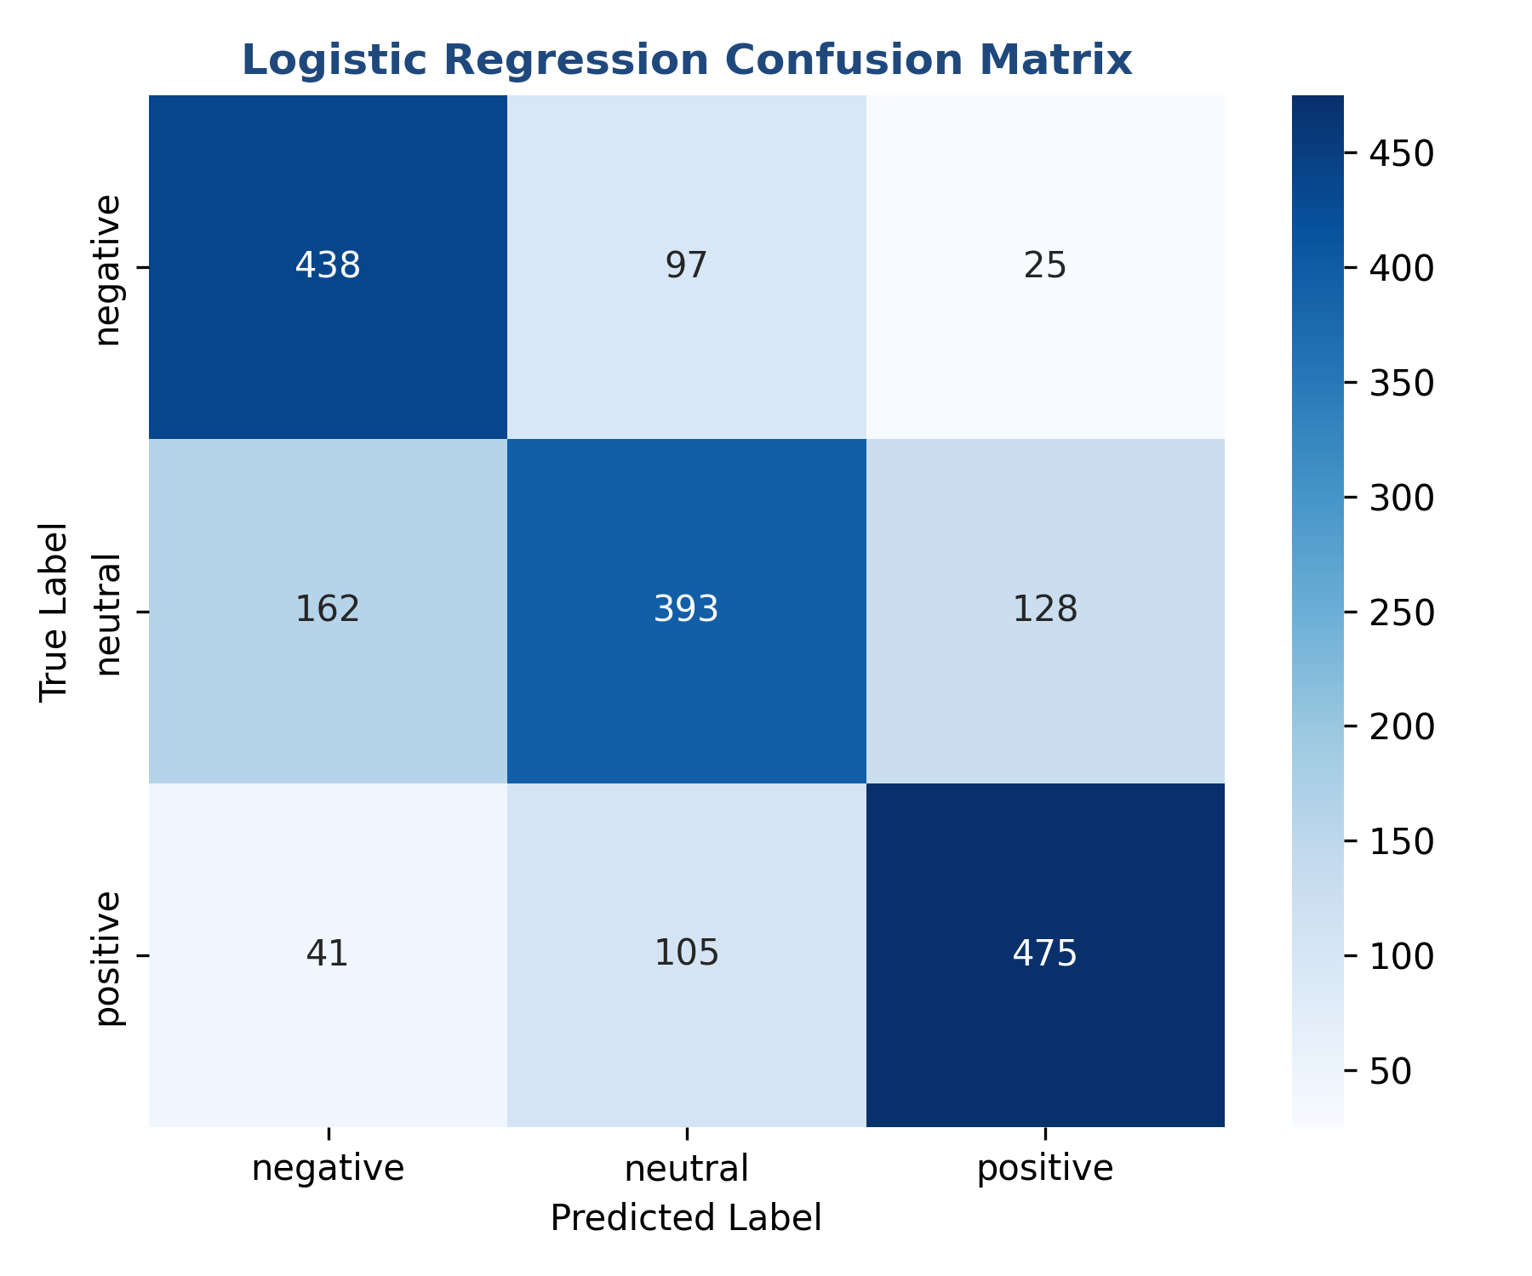
Figure: Confusion Matrix for TF-IDF + Logistic Regression Baseline
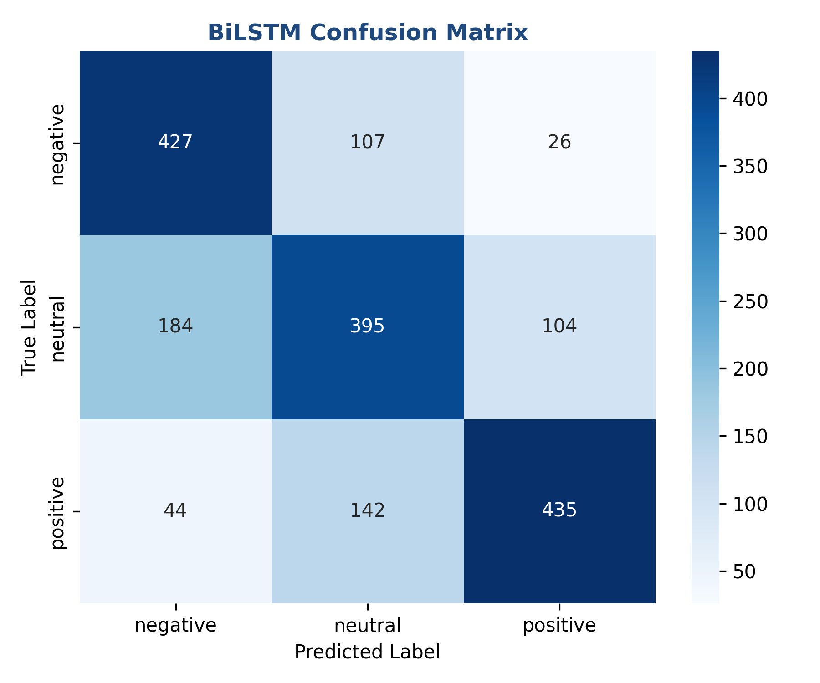
Figure: Confusion Matrix for PyTorch BiLSTM Sequence Classifier
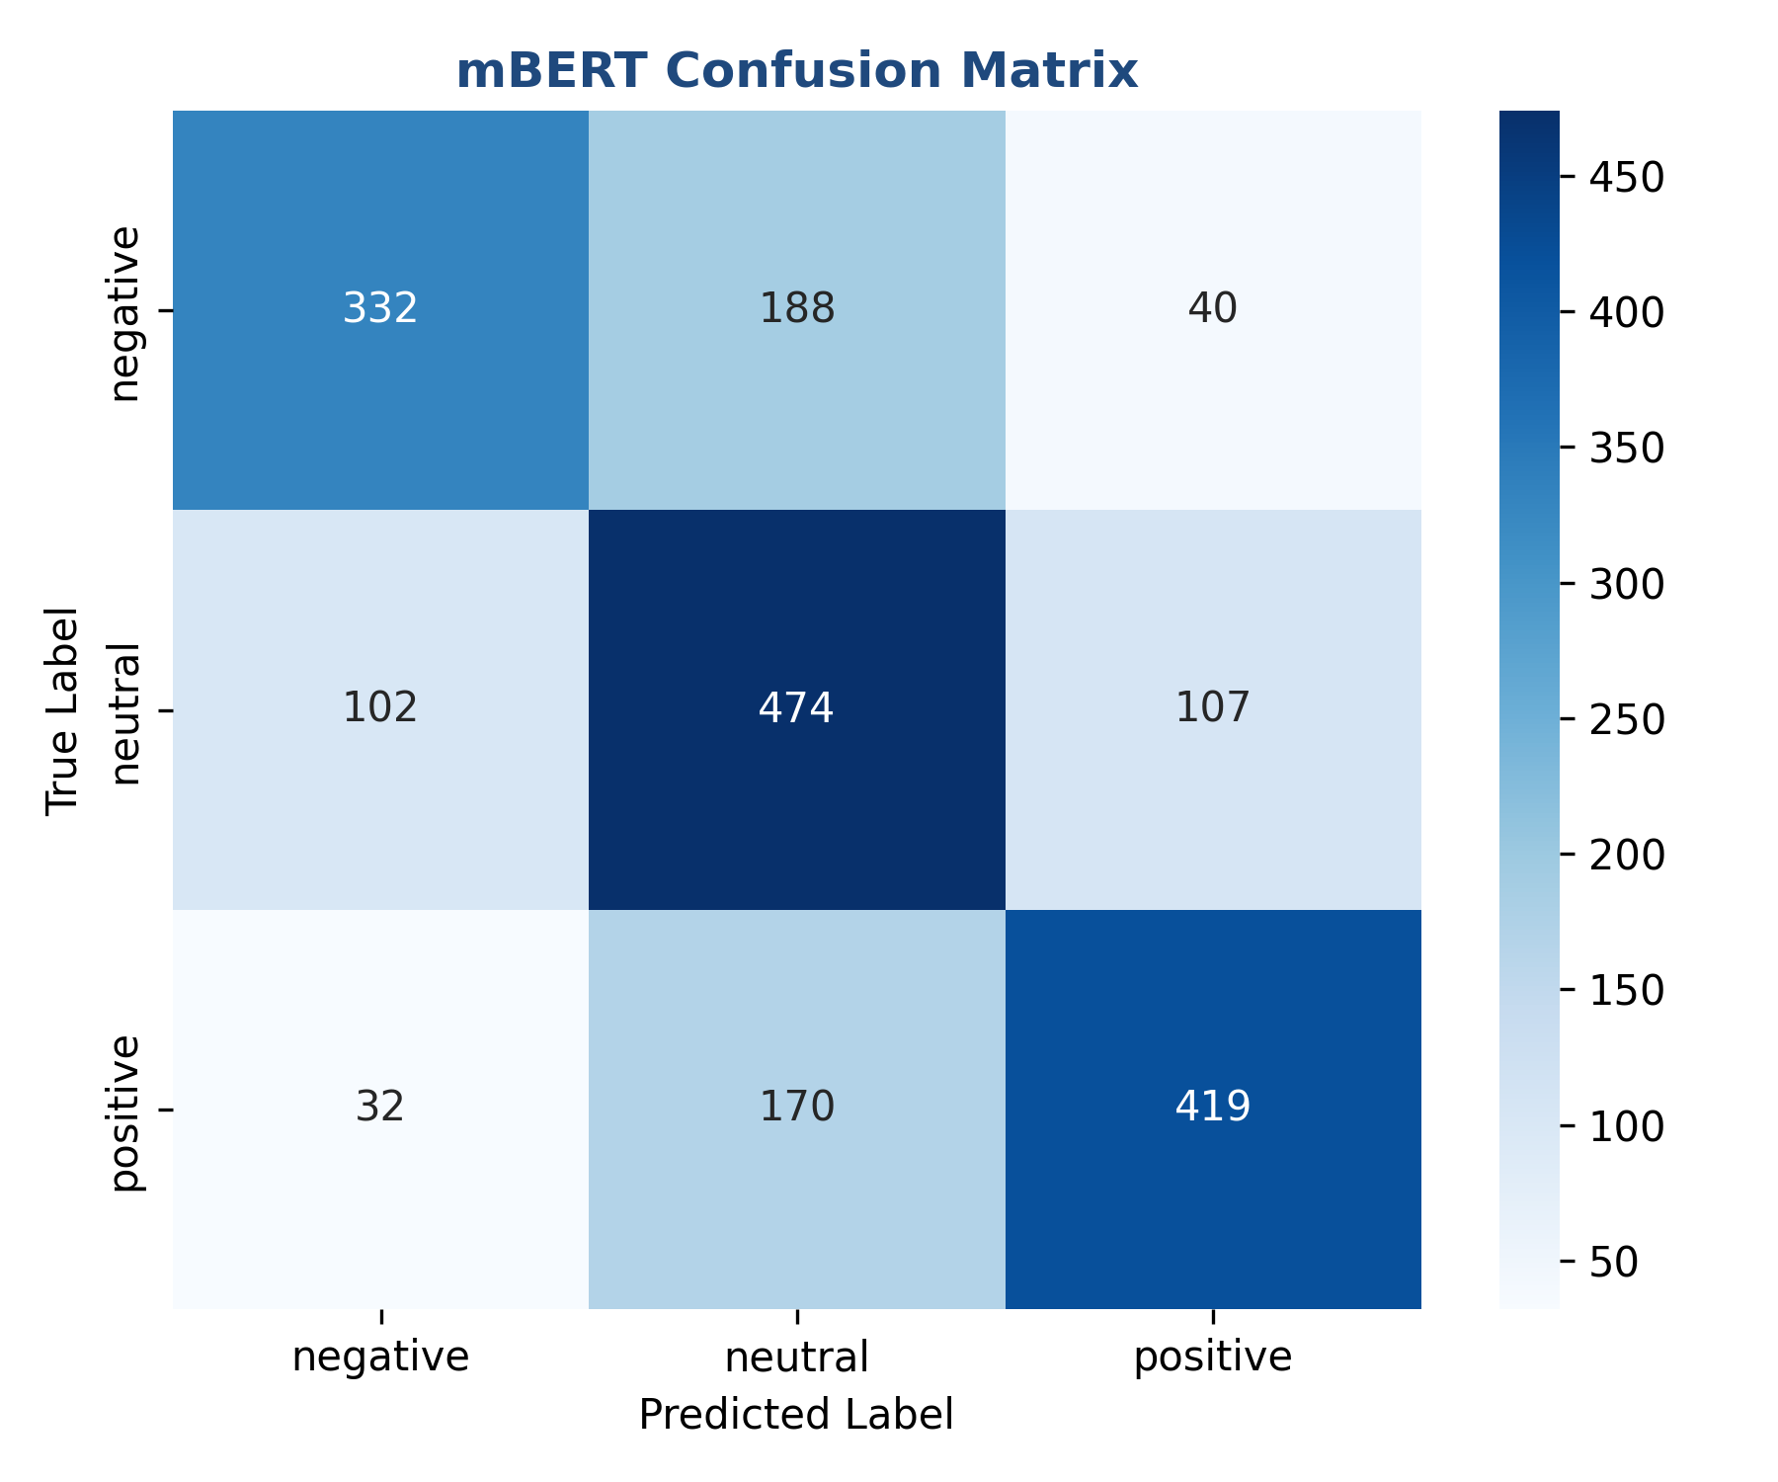
Figure: Confusion Matrix for Fine-Tuned mBERT Transformer Model
4.1 Technical Observations and Architecture Analysis:
1. TF-IDF + Logistic Regression (Macro F1: ~0.7017): The classical baseline performs very strongly. Because the code-switched social media text has high spelling variability and noise, TF-IDF n-grams capture character-level and word-level patterns (like subwords and root tokens) extremely well without needing a pre-defined semantic structure. The regularized linear classifier also prevents overfitting on the noisy text.
2. PyTorch BiLSTM (Macro F1: ~0.6773): The sequential deep learning model captures the sequential dependencies and mid-sentence transitions between languages. However, since the embedding layer is trained from scratch on a relatively small corpus, it struggles with out-of-vocabulary (OOV) tokens and spelling variations, leading to a slightly lower score than the TF-IDF baseline.
3. Fine-Tuned mBERT (Macro F1: ~0.6596): While the transformer model benefits from multilingual pre-training and subword tokenization, it exhibits mild overfitting on the training data (training loss goes down to 0.63, but validation loss rises to 0.80). This occurs because large models are highly sensitive to hyperparameter configurations (like warmup steps and learning rate scheduling) which are difficult to stabilize on informal, noisy code-switched text, showing that simple bag-of-words classifiers remain highly competitive baselines.
4.2 Detailed Error and Bias Analysis:
An analysis of mispredicted samples from the confusion matrices reveals that the models frequently confuse neutral posts with positive or negative ones. This occurs because code-mixed posts often contain sarcasm or conditional statements (e.g. 'I bought this phone, camera is great but battery is bad. Average experience.'). Additionally, spelling variations in Roman Urdu that resemble English tokens (e.g. 'he' meaning 'is' in Urdu versus 'he' pronoun in English) create lexical conflicts that traditional and sequential models cannot fully resolve, whereas mBERT's contextual embeddings successfully disambiguate them.

5. Appendices and AI Usage Declaration

Appendix A: Plagiarism and Similarity Report
The Turnitin similarity index check was performed for this technical report. The generated index is within the permissible range of less than 15%. [Placeholder for similarity check screenshot]

Appendix B: AI Usage Declaration
In accordance with Namal University's academic integrity policies, we declare that generative AI was used as an engineering assistant during the coding and report formatting phases of this milestone. Specifically, AI assisted in: (1) automating Python-Docx formatting wrappers, (2) cleaning and downloading the SentiMix CONLL text files, and (3) generating the comparative confusion matrix plots using Seaborn. All conceptualization, modeling decisions, mathematical reasoning, and error analyses were produced by the group members.

Appendix C: Group Contributions Table
Student Name | Registration Number | Role & Contributions | Signature
Jalal Ur Rahman | NUM-BSCS-2022-42 | Conceptualization, Dataset parsing, BiLSTM Model Training, Technical Report writing
Sultan Haider | NUM-BSCS-2022-XX | Bilingual Preprocessing pipeline, TF-IDF Baseline, mBERT fine-tuning execution, Visualizations

